Pendulums and Resonance
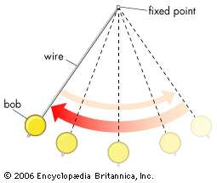
- A pendulum is a weight on a string (or stick) that hangs down and swings back and forth
- The amplitude of a pendulum is how high it swings
- The period of a pendulum is how long it takes to make one full back-and-forth swing. Each pendulum has its own preferred period of swinging. We’ll do some experiments to figure out what determines that preferred period.
- Pendulums are used to keep time (grandfather clocks) and to help explain how fast different animals walk!

Work with a partner (and / or a parent)
When designing an experiment, scientists usually change one variable at a time and compare to a control to see if the outcome changed. We will change one variable at a time to see if it affects the frequency of the pendulum.

Pendulum Period and Amplitude
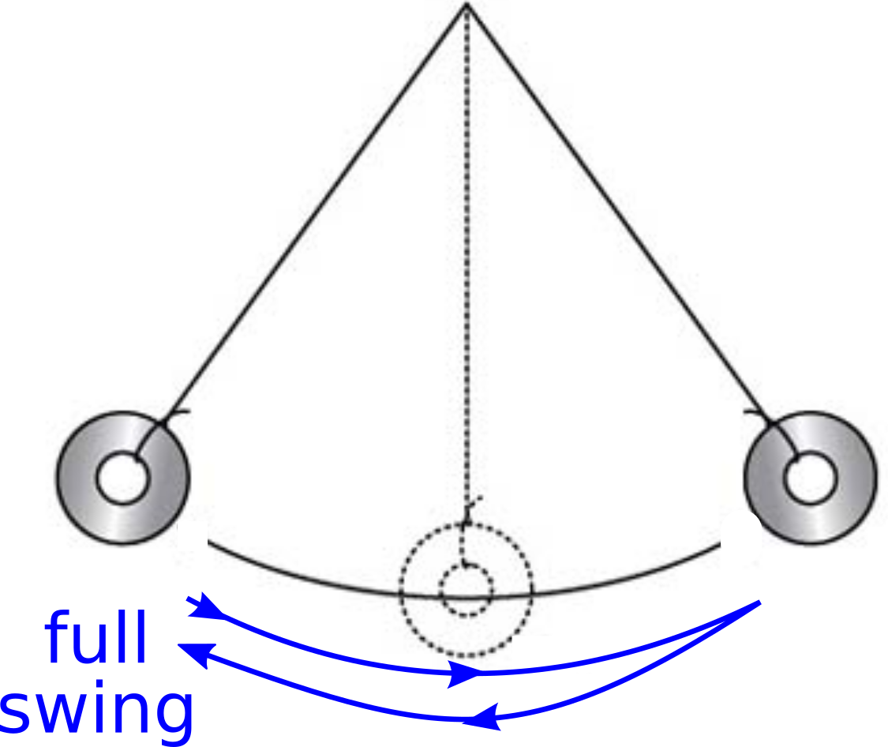
1. Cut a piece of string approximately 16” long.
2. Tie a washer close to one end of the string.
3. Tie other end of the string to the bottom of a clothes hanger.
4. One partner: hold the top of the hanger firmly (the hanger itself should not move). Pull up the washer a little and let it swing.
5. Other partner: use the timer to measure how long it takes the pendulum to make 10 full back-and-forth swings. You may find it easier to count 20 half-swings instead. Record the time in the table below. This is your control.
6. Repeat with larger amplitude swings, by pulling back the washer twice as far. Record the time in the table.

Time for 10 full swings
Small amplitude
Large amplitude

Did changing the amplitude have a big effect on the period of the pendulum?

Pendulum Period and Mass

1. Cut another string approximately 16” long.
2. Tie 4 washers to the string and tie the other end to the hanger so that the length of your new pendulum is exactly the same as the length of your first one.
3. Switch which partner does the timing. Hold the old pendulum out of the way while you hold the hanger. Time how long it takes the new pendulum to make 10 full back-and-forth swings.

 | Time for 10 full swings
Small mass (1 washer) | (copy from before)
Large mass (4 washers)

Did changing the mass of the pendulum have a big effect on its period?

Pendulum Period and Length
1. Cut another string approximately 8” long.
2. Tie a washer to the string and tie the other end to the hanger between the two previous pendulums so that the length of your new pendulum is approximately half the length of your first one.
3. Hold the old pendulums out of the way while you hold the hanger. Time how long it takes the new short pendulum to make 10 full back-and-forth swings.

 | Time for 10 full swings
Long pendulum | (copy from before)
Short pendulum

Did changing the length of the pendulum have a big effect on its period?

The leg of a walking animal can be thought of as a pendulum. Based on your experiment, who do you think swings their legs fastest when walking? (circle one)

ants humans elephants

Pendulums and Resonance (if you have time!)

Resonance describes a phenomenon where pushing a swinging system with the same period as its natural, preferred period makes it swing very high. Resonance explains why you have to push with just the right rhythm to get a child swinging on a swing. Resonance can make entire structures (like a bridge!) collapse if they happen to be pushed with just the right period.
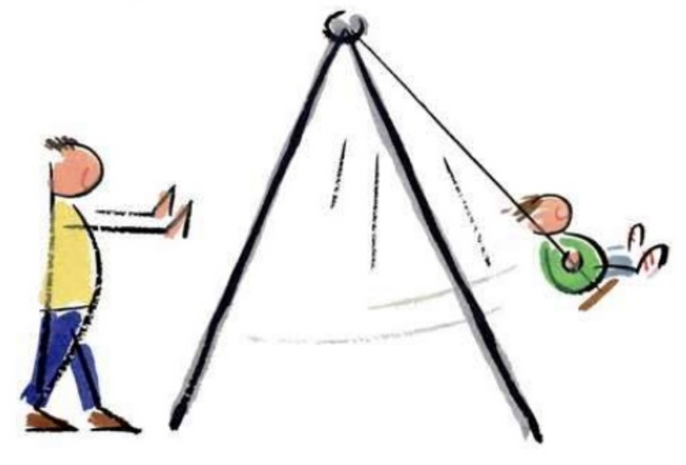
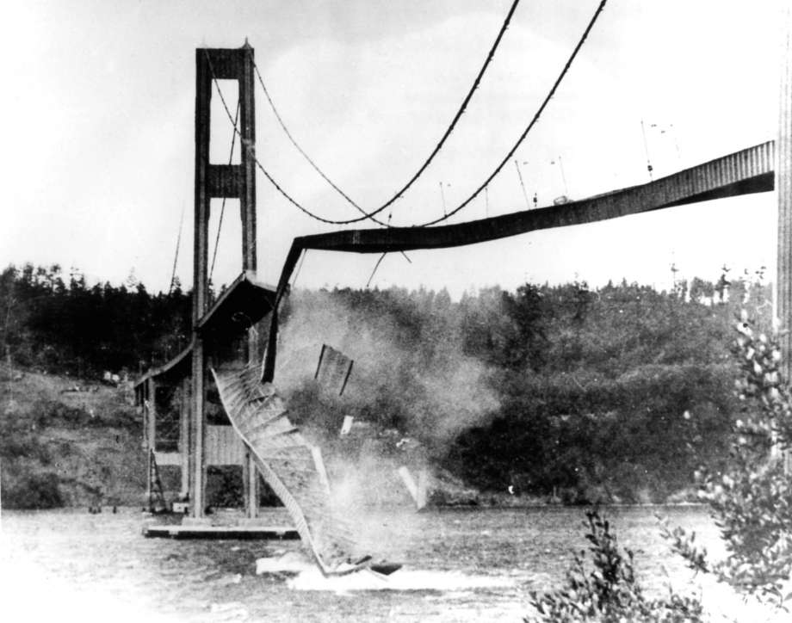
1. Release all three of your pendulums (long, short, and long). Make a prediction:

If you set one long pendulum swinging with high amplitude what will happen to the other two pendulums? Will one or both of them swing? Will one swing more than the other?

2. Hold the hanger steady so that all of the pendulums hang without moving. Pull back one long pendulum with high amplitude. What happens? Be patient and watch!

Swinging? A lot or a little?
Short pendulum
Other long pendulum

Was your prediction right?

